**Lab 1**

**1 Introduction**

**1.1 Target**

* Know how to read datasheet.
* Design simple circuit with 74 familly.
* Optimize boolean expression by using boolean algebra and K-map.
* Know how to use VOM.

**1.2 Contents**

* Investigate some IC in 74 familly.
* Optimize boolean expression and implement it by using 74s IC.

**2 Exercises**

Note: Take pictures for every circuits that are implemented and attach its into your report.

**Ex 1**: Investigate the function of 2 in 6 IC that was mentioned. Sources of inputs are switch, destinations of outputs are LEDs. Draw your circuit and fill the two truth tables below.

IC 7408: X = AB

|  |  |  |
| --- | --- | --- |
| **Input 1** | **Input 2** | **Output** |
| 1 | 1 | 1 |
| 1 | 0 | 0 |
| 0 | 1 | 0 |
| 0 | 0 | 0 |

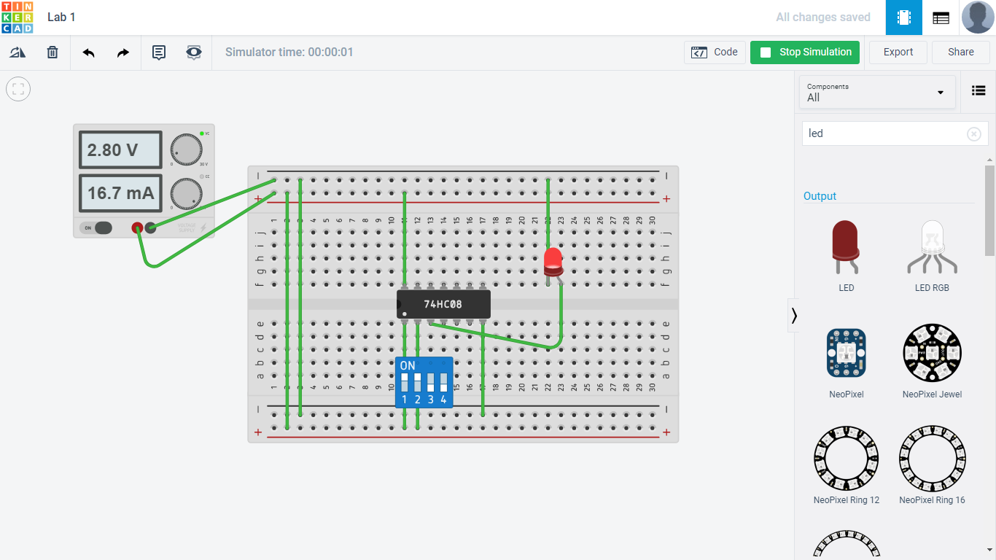

IC 7432: X = A + B

|  |  |  |
| --- | --- | --- |
| **Input 1** | **Input 2** | **Output** |
| 1 | 1 | 1 |
| 1 | 0 | 1 |
| 0 | 1 | 1 |
| 0 | 0 | 0 |

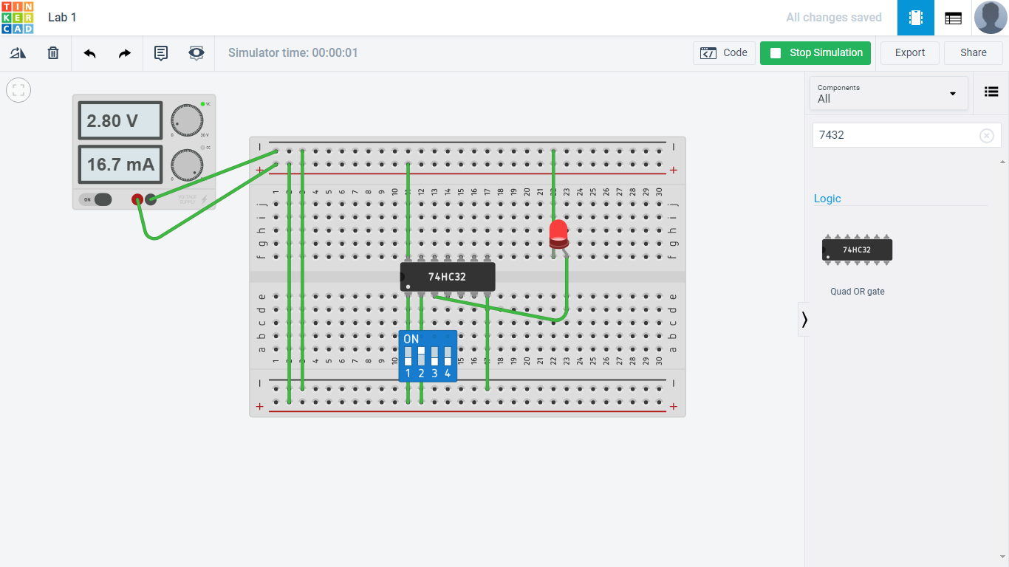

**Ex 2**: Optimize these expressions below by using bolean algebra for x, K-map for z. Present each step which you do in the report. Draw the circuit and implement your design.

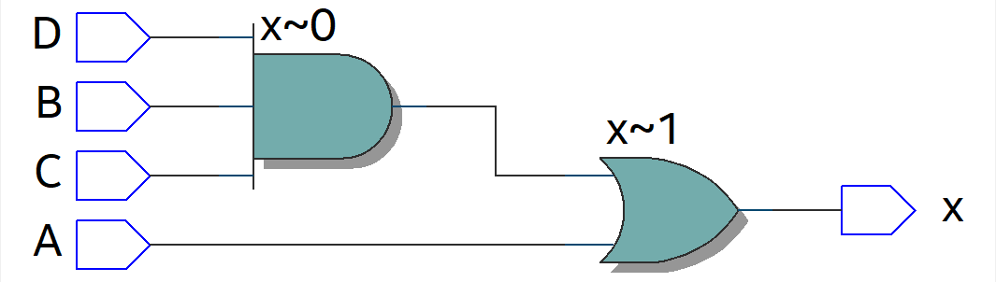

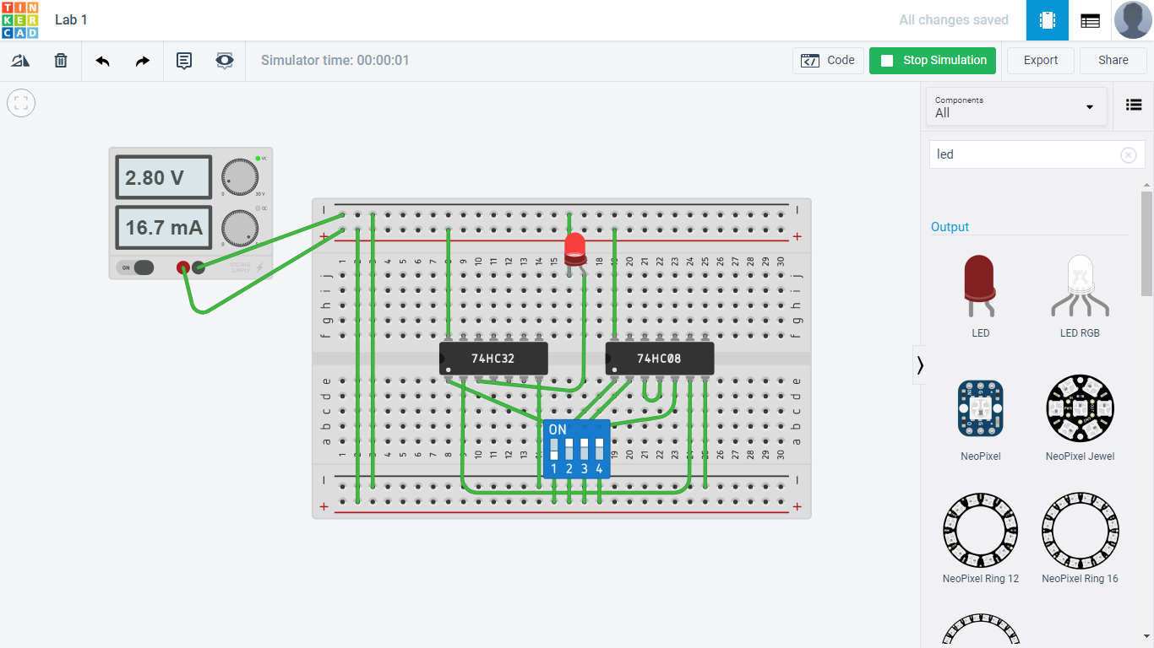

K-Map:

|  |  |  |
| --- | --- | --- |
|  |  |  |
|  | 0 | 0 |
|  | 0 | 1 |
|  | 1 | 0 |
|  | 0 | 0 |

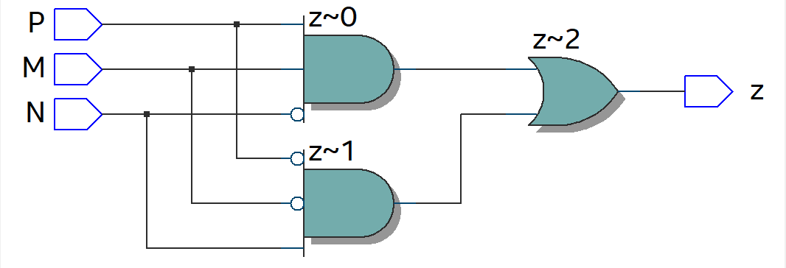

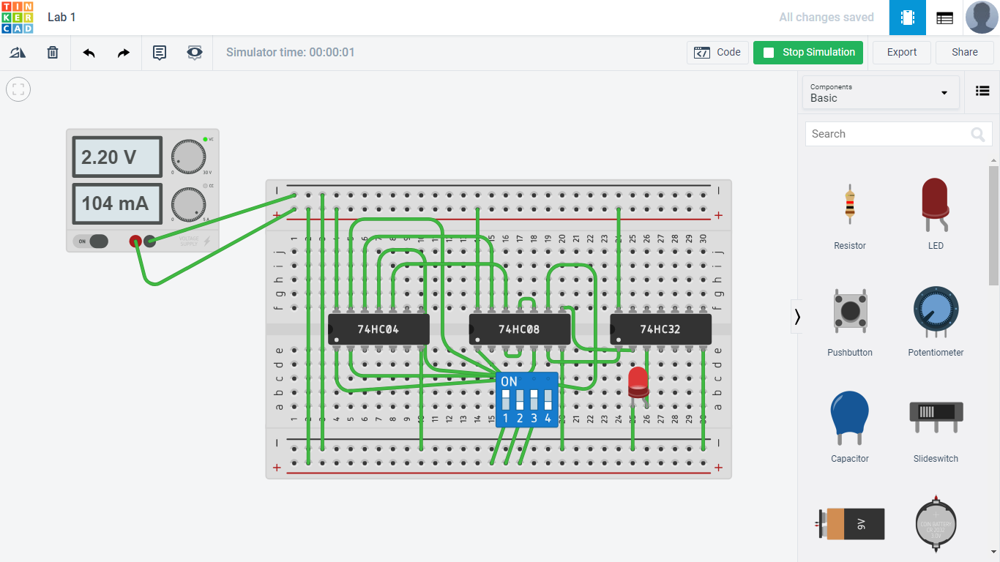

**Ex 3**: Use 7404s, 7408s, 7432s to implement these boolean expressions below. Draw your circuit and fill the truth table below.

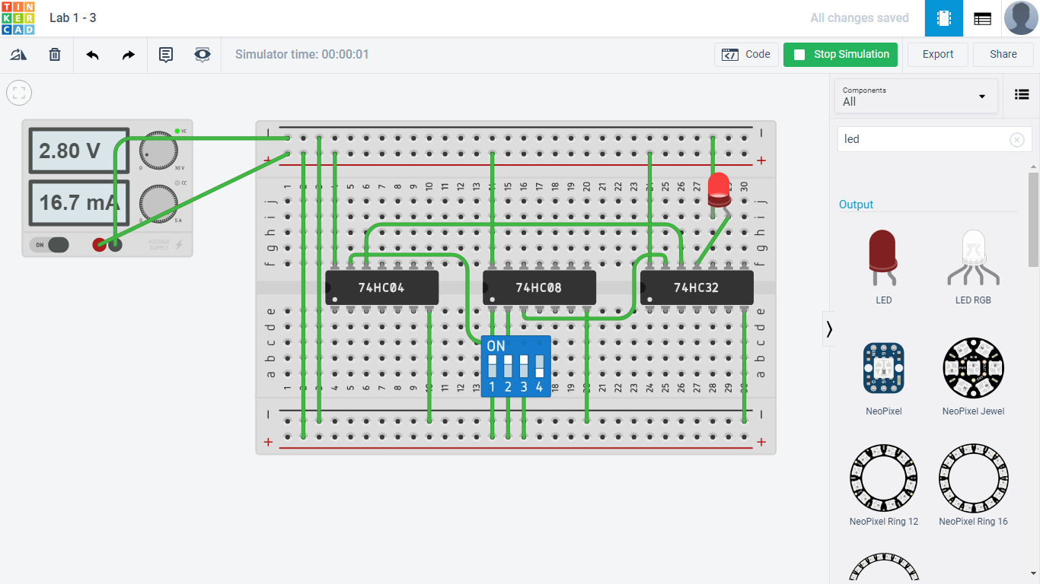

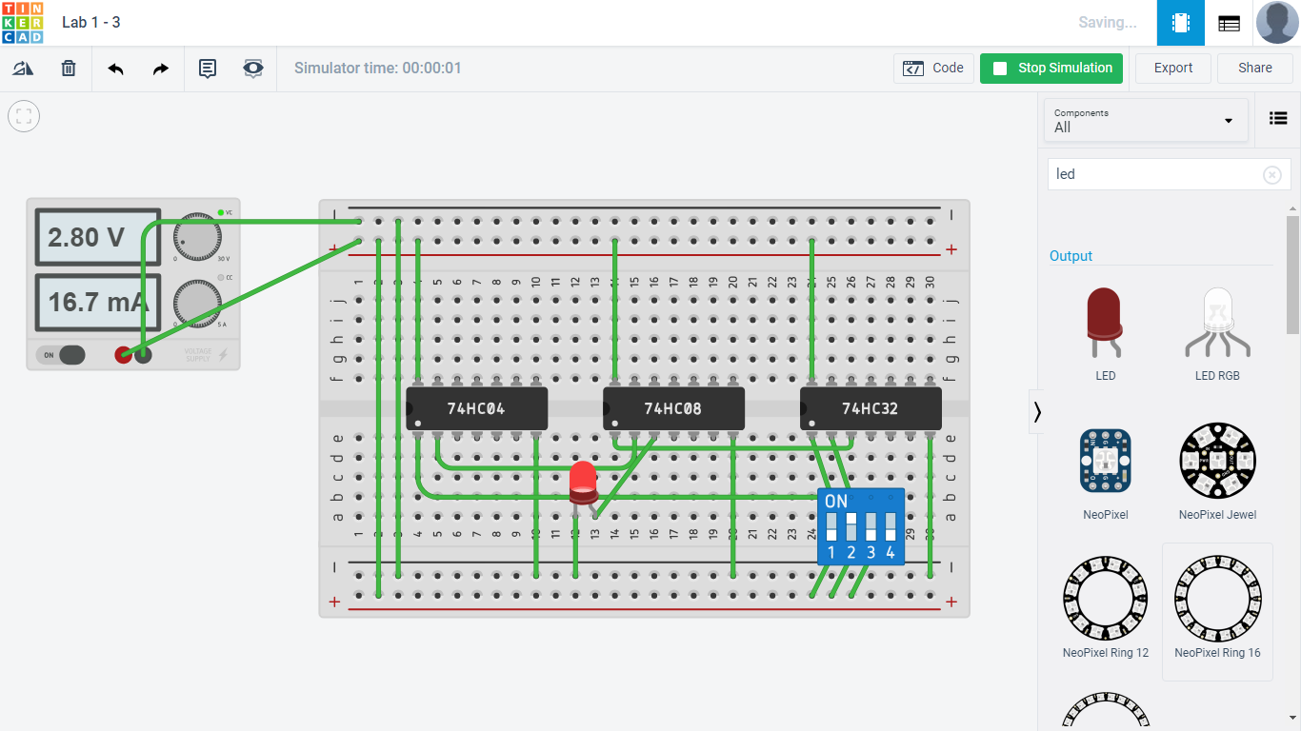

|  |  |  |  |  |  |
| --- | --- | --- | --- | --- | --- |
|  |  |  |  |  |  |
| 1 | 1 | 1 | 1 | 0 |  |
| 1 | 1 | 0 | 1 | 1 |  |
| 1 | 0 | 1 | 0 | 0 |  |
| 1 | 0 | 0 | 1 | 1 |  |
| 0 | 1 | 1 | 0 | 0 |  |
| 0 | 1 | 0 | 1 | 1 |  |
| 0 | 0 | 1 | 0 | 0 |  |
| 0 | 0 | 0 | 1 | 0 |  |